Probabilistic inversion of seismic data for reservoir petrophysical characterization: Review and examples

Dario Grana¹, Leonardo Azevedo², Leandro de Figueiredo³, Patrick Connolly⁴, and Tapan Mukerji⁵

ABSTRACT
The physics that describes the seismic response of an inter- val of saturated porous rocks with known petrophysical prop- erties is relatively well understood and includes rock physics, petrophysics, and wave propagation models. The main goal of seismic reservoir characterization is to predict the rock and fluid properties given a set of seismic measurements by combining geophysical models and mathematical methods. This modeling challenge is generally formulated as an inverse problem. The most common geophysical inverse problem is the seismic (or elastic) inversion, i.e., the estimation of elastic properties, such as seismic velocities or impedances, from seismic amplitudes and traveltimes. The estimation of petro- physical properties, such as porosity, lithology, and fluid sat- urations, also can be formulated as an inverse problem and is
generally referred to as rock-physics (or petrophysical) inver- sion. Several deterministic and probabilistic methods can be applied to solve seismic inversion problems. Deterministic al- gorithms predict a single solution, which is a “best” estimate or the most likely value of the model variables of interest. In probabilistic algorithms, on the other hand, the solution is the probability distribution of the model variables of interest, which can be expressed as a conditional probability density function or a set of model realizations conditioned on the data. The probabilistic approach provides a quantification of the un- certainty of the solution in addition to the most likely model. Our goal is to define the terminology, present an overview of probabilistic seismic and rock-physics inversion methods for the estimation of petrophysical properties, demonstrate the fundamental concepts with illustrative examples, and discuss the recent research developments.

INTRODUCTION
Seismic reservoir characterization (or seismic reservoir modeling [SeReM]) refers to a subdiscipline of exploration geophysics that aims to improve the reservoir description in terms of rock and fluid properties based on geophysics models (i.e., rock physics, petro- physics, geomechanics, and seismology) using seismic data as well as core measurements and well logs if available. One of the primary tasks of seismic reservoir characterization is the prediction of res- ervoir properties, i.e., elastic and petrophysical properties of satu- rated porous rocks, from the available geophysical data (Doyen, 2007; Avseth et al., 2010; Bosch et al., 2010; Simm and Bacon,
2014; Azevedo and Soares, 2017; Grana et al., 2021). This task is generally referred to as seismic and/or rock-physics inversion, depending on the parameterization of the reservoir model.
In this context, the term seismic inversion traditionally refers to the acoustic or elastic inversion of seismic data for the prediction of seis- mic properties, such as velocities or impedances, and density (Fig- ure 1a). The term rock-physics (or petrophysical) inversion refers to the prediction of rock and fluid properties from a set of seismic mea- surements or attributes (Figure 1b and 1c). Examples of rock and fluid properties include not only porosity, lithology (i.e., mineral vol- umes or facies), and fluids saturation but also could include other properties such as fracture density and orientation. The available data

Manuscript received by the Editor 29 November 2021; revised manuscript received 17 May 2022; published ahead of production 16 June 2022; published online 25 July 2022.
¹University of Wyoming, Department of Geology and Geophysics, Laramie, Wyoming, USA. E-mail: dgrana@uwyo.edu (corresponding author).
²University of Lisbon, Instituto Superior Técnico, Department of Geoscience, Lisbon, Portugal. E-mail: leonardo.azevedo@tecnico.ulisboa.pt.
³LTrace, Florianopolis, Santa Catarina, Brazil. E-mail: leandrop.fgr@gmail.com.
⁴PCA Ltd., Ascot, UK. E-mail: patrick.connolly.451@gmail.com.
⁵Stanford University, Department of Energy Resources Engineering, Stanford, California, USA. E-mail: mukerji@stanford.edu.
© 2022 Society of Exploration Geophysicists. All rights reserved.

M199

generally include seismic data but, in many practical applications, the input data are the set of seismic properties obtained from seismic in- version, which means that the data are not direct measurements but are the results of a modeling process. In other words, the rock-physics inversion for reservoir characterization can be performed sequentially in two steps (i.e., seismic and rock-physics inversions, Figure 1b) or a single step (i.e., a joint seismic and rock-physics inversion, Figure 1c). The physics relations used in the rock-physics inversion are generally referred to as the rock-physics model (Mavko et al., 2020). Unlike seismic inversion, the details of the rock-physics model formulation vary depending on the geologic and sedimentary environment, although the basic underlying fundamentals of effective medium the- ories are applicable to all depositional environments.
In this review, we focus on inversion methods for seismic reservoir characterization in which the state-of-the-art research primarily fo- cuses on the probabilistic inversion of seismic data for petrophysical properties, as opposed to seismic imaging in which ongoing research focuses on full-waveform inversion methods for elastic variables (Virieux and Operto, 2009). Rock-physics (or petrophysical) inver- sion has made significant progress recently (Doyen, 2007; Bosch et al., 2010; Grana et al., 2021); however, recent advances, in par- ticular probabilistic methods, are still not completely integrated with industry best practices and common geomodeling workflows. In many practical applications, simple deterministic inversion methods and simplified rock-physics models often are used to estimate rock and fluid properties. A typical example is the prediction of porosity from P-wave velocity assuming a linear relation between the two properties and performing a simple linear inversion. However, rock-physics models are generally not linear and might require more advanced constitutive equations and inverse methods. The solution of the inverse problem is nonunique due to the nonbijectivity of the geophysical equations, the heterogeneity in spatial distributions
and correlations of rock properties, the noise, and the band-limited nature of seismic data. Therefore, a suitable inversion method should estimate the uncertainty in the prediction as well as the most likely model. The goal of probabilistic inversion is not to build a single model of the reservoir and add some quantitative information related to uncertainty, but to account for the inherent uncertainty in the solution of the inversion problem. The relative uncertainties of the input data and parameters can change the most likely model and hence ignoring those risks introduces bias. Probabilistic inversions can therefore reduce bias in the solution and provide a model of un- certainty for decision-making purposes.
Probabilistic approaches to inverse problems provide a natural framework for seismic and rock-physics inversion. In a probabilistic approach, the solution of the inverse problem can be expressed as a probability density function (PDF) of the model properties or a set of model realizations that capture the uncertainty in the model. Probabilistic inversion methods providing the estimation of the pos- terior probability distribution of the model parameters can be com- bined with geostatistical simulation algorithms to sample from the posterior distribution and provide multiple model realizations with spatial correlation. Most probabilistic methods for inverse problems use a Bayesian approach (Tarantola, 2005), in which the prior dis- tribution of the model parameters (assumed from a priori knowl- edge) is combined with the likelihood function that links the data to the model parameters, to estimate the posterior distribution. One of the main advantages of the Bayesian framework is the ability to integrate the prior knowledge of the unknown random variable with data conditioning from multiple sources. However, not all sto- chastic methodologies are formulated in a Bayesian framework. This is the case of stochastic optimization methods that do not explicitly require a prior model but stochastically perturb an initial realization until convergence.
Several classifications of the available petro-
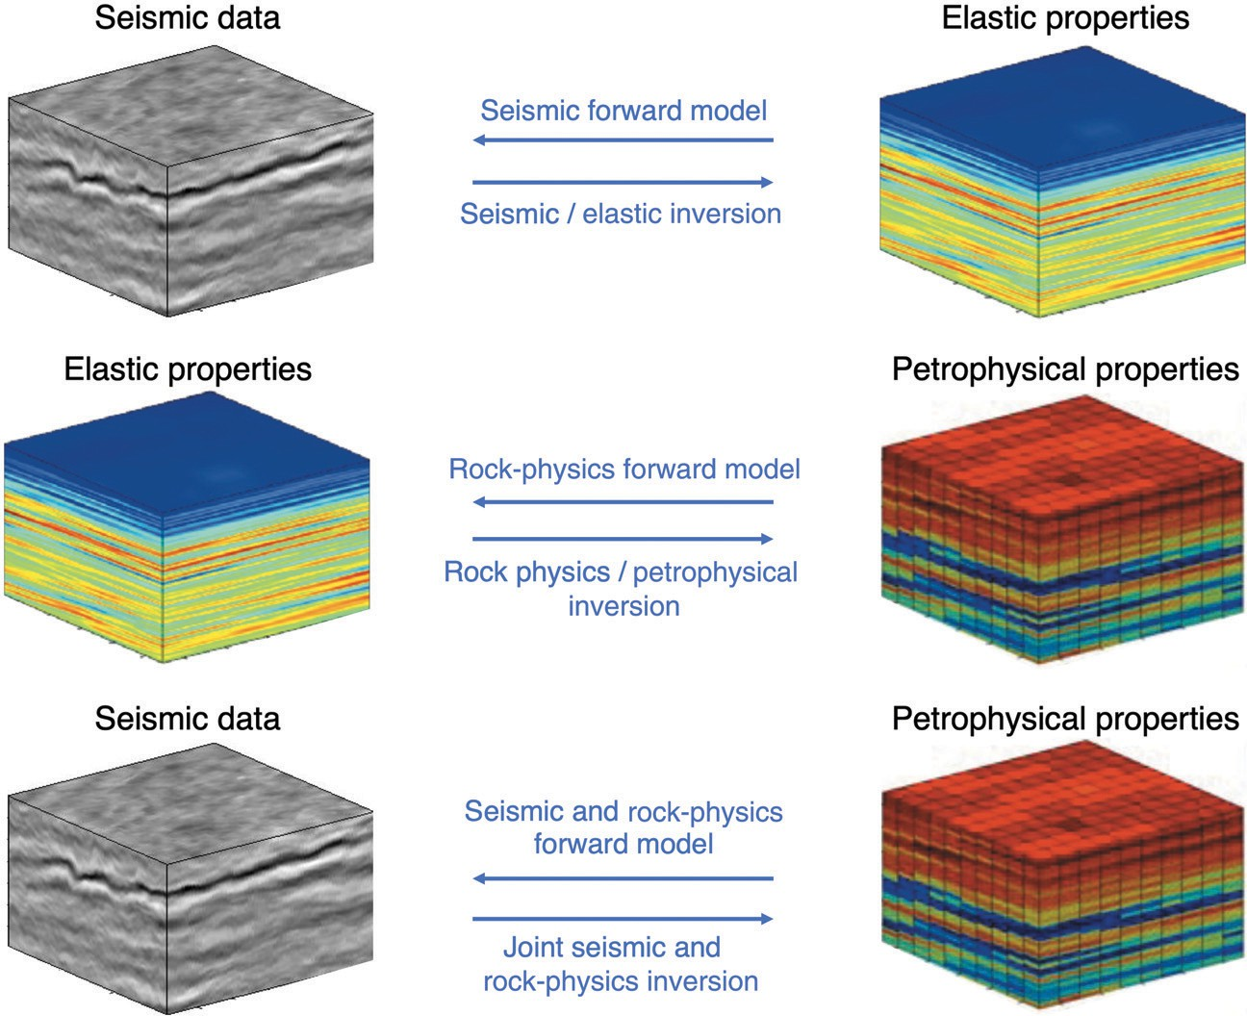
physical inversion methods can be proposed, such as Bayesian versus non-Bayesian, stochas- tic sampling versus optimization, continuous versus discrete, or single-loop versus multistep inversion. Here, we propose to classify the available methods into four main categories:
(1) Bayesian analytical inversion, (2) Monte Carlo methods, (3) stochastic optimization, and
(4) probabilistic deep learning. This is not a strict classification as some methods can be classified in multiple categories. For example, some sam- pling methodologies can be considered Monte Carlo methods as well as stochastic optimization algorithms. Similarly, probabilistic deep learning algorithms can be considered as stochastic opti- mization. Some methods might be hybrid and combine multiple approaches. For instance, some Bayesian analytical inversions might re- quire Monte Carlo sampling for the evaluation of the full posterior distribution. Markov chain Monte Carlo (MCMC) methods can be consid- ered part of the stochastic optimization group; however, MCMC is a Bayesian method, whereas stochastic optimization methods are not neces-

Figure 1. Inversion problems in seismic reservoir characterization and corresponding terminology.
sarily Bayesian and do not always require a prior distribution.

The first two categories are based on the Bayesian approach in which we aim to estimate the posterior probability distribution of the model variables. In the Bayesian analytical inversion category, we include only the Bayesian inversion methods that provide an ana- lytical solution of the posterior PDF conditioned on the measured data (e.g., the distribution of reservoir rock and fluid properties condi- tioned on seismic data). The analytical solution is generally available only for linear problems that meet statistical assumptions for the prob- ability distributions of the prior model and data errors. The application of these methods to seismic reservoir characterization requires the lin- earization of the seismic and rock-physics models. Monte Carlo meth- ods, such as Monte Carlo acceptance-rejection sampling and MCMC, are iterative algorithms in which a large set of models is generated to approximate the posterior distribution (Diggle and Gratton, 1984; Geyer, 1992; Chib and Greenberg, 1995; Brooks et al., 2011; Gelman et al., 2013). In Monte Carlo acceptance-rejection sampling, multiple realizations of the model variables (e.g., reservoir models of rock and fluid properties) are generated from a prior distribution and accepted or rejected according to the likelihood of the predictions compared with the real data (e.g., the predicted seismic response); the accepted models are used to approximate the posterior distribution. A similar approach to Monte Carlo acceptance-rejection sampling is repre- sented by approximate Bayesian computation algorithms, in which a set of model parameters is generated from a prior distribution, the likelihood function is approximated by simulations, and the mis- match between the predicted and real data is evaluated to accept or reject the proposed model (Csillery et al., 2010). In MCMC methods, such as Metropolis-Hastings or Gibbs sampling algorithms, a se- quence of models (a chain) is proposed and a model is accepted or rejected according to the posterior probability of the current model given the data compared with the posterior probability of the previous model in the chain until the chain converges to the posterior distri- bution. In stochastic optimization algorithms, a set of models is iter- atively generated and stochastically perturbed until the mismatch between predicted and measured data is lower than a given threshold; the model with the lowest misfit value is the optimal solution of the inverse problem. The selection of the optimal model requires the assumption of a measure of the mismatch (i.e., the norm of the error) between predicted and measured seismic data. In general, analytical algorithms are faster and computationally more efficient than numeri- cal methods, but they require the linearization of the forward model, as well as restrictive and sometimes geologically unrealistic assump- tions about the probability distributions of the model parameters. Acceptance-rejection sampling and stochastic optimization algo- rithms are more computationally demanding because of the large number of realizations required to obtain a good approximation of the posterior function. Unlike Monte Carlo methods, stochastic opti- mization and probabilistic deep learning algorithms are not neces- sarily framed in a Bayesian setting, and they might not require a prior distribution of the model variables but an initial realization or set of realizations. Stochastic optimization and Monte Carlo sampling algorithms have represented the computational foundations of nonlin- ear geophysical inversion for several decades. In the context of convex functions optimization, stochastic optimization algorithms are generally more efficient computationally than sampling algorithms, whereas, for nonconvex functions resulting from mixture modeling, sampling methods can be as efficient as optimization algorithms (Ma et al., 2019). In recent years, several deep learning algorithms devel- oped in computer science have been recently applied to geophysical
inverse problems. These algorithms often are based on frequentist approaches to perform statistical inference; however, Bayesian ap- proaches such as Bayesian neural networks have gained popularity in geoscience applications of deep learning (Wang and Yeung, 2016; Wilson and Izmailov, 2020). Reservoir model realizations for sampling, optimization, and deep learning are generally created using geostatistical techniques, such as stochastic sequential simulation (Deutsch and Journel, 1997) based on variograms (or two-point geo- statistics), multipoint statistics simulation (Mariethoz and Caers, 2014), process-mimicking simulations, or object-based simulations (Linde et al., 2015).
In the following sections, we first present a literature review of the main probabilistic inversion algorithms presented in the litera- ture and then show some examples of inversion methodologies.

LITERATURE REVIEW
Seismic reservoir characterization is based on several physical models including seismic wave propagation (e.g., Aki and Richards, 1980; Sheriff and Geldart, 1995) and rock physics (Avseth et al., 2010; Mavko et al., 2020). The goal is to predict the model variables that fit the data according to the physical model. This task is generally challenging due to the multiple sources of uncertainty that affect the data, such as noise and limited bandwidth, heterogeneity in spatial distributions of rock properties, and the approximations in the physi- cal relations, which makes the solution nonunique. The inverse theory is a branch of mathematics that aims to compute the model variables of interest from the measured data, assuming that the physi- cal relation is known or partially known (Tarantola and Valette, 1982; Tarantola, 2005). Inverse methods for geophysical applications in- clude deterministic and probabilistic approaches (Tarantola, 2005; Aster et al., 2011; Sen and Stoffa, 2013). Seismic reservoir charac- terization generally focuses on a specific depth interval, as opposed to seismic imaging in which the interval of interest starts at the surface. Linearized approximations of seismic wave propagation often are as- sumed, such as the linearized amplitude-variation-with-offset (AVO) approaches (e.g., Aki and Richards, 1980; Russell, 1988). As our focus is on the petrophysical rock and fluid properties, such as poros- ity, lithofacies, mineral, and fluid fractions, seismic models are com- bined with rock-physics equations (Mavko et al., 2020) to map the properties of interest into their seismic response. Doyen (2007) provides an excellent overview of modeling methods for seismic res- ervoir characterization. Bosch et al. (2010) provide a summary of methodologies that are now well established in the geomodeling workflow. Avseth et al. (2010) and Simm and Bacon (2014) focus on the geologic interpretation and practical application of SeReM techniques. Azevedo and Soares (2017) focus on the integration of geostatistical methods in SeReM. The fundamentals, as well as the state-of-the-art of seismic reservoir characterization, are described in Grana et al. (2021).
Probabilistic inversion methods were first proposed for acoustic and elastic inversion several decades ago (Duijndam, 1988a, 1988b; Sen and Stoffa, 1991; Mallick, 1995). At the same time, many works on the integration of geostatistical methods and seismic mod- eling have been proposed with the goal of generating multiple res- ervoir models conditioned on seismic amplitudes as well as honoring available well data and the spatial two-point correlation as well as spatial multipoint statistical structure (Doyen, 1988; Doyen and Guidish, 1992; Bortoli et al., 1993; Haas and Dubrule, 1994; Doyen and den Boer, 1996; González et al., 2008; Jeong et al., 2017). The

parallel developments in statistical rock physics and petrophysics modeling allowed the incorporation of rock-physics relations in the probabilistic seismic inversion workflows (Mukerji et al., 1998, 2001a, 2001b; Sams et al., 1999; Torres-Verdín et al., 1999). Subsequent publications integrating rock-physics modeling and seismic inversion for the prediction of petrophysical properties led to the introduction of the term “petrophysical inversion” in which a rock-physics model (or petroelastic model) is first calibrated from the available well data to define a physical relation between petro- physical properties and elastic attributes at the well location and then the petrophysical properties of interest are estimated from seismic data in the reservoir model (Bosch, 1999; Mazzotti and Zamboni, 2003; Bornard et al., 2005; Coléou et al., 2005; Bachrach, 2006; Spikes et al., 2008; Bosch et al., 2009). In the same context, the stat- istical rock-physics approach (Mukerji et al., 2001a, 2001b; Eidsvik et al., 2004a) was developed to account for the uncertainty in the rock-physics models. Statistical rock physics allows for Bayesian classification of inverted seismic attributes obtained from determin- istic or stochastic seismic inversion (Avseth et al., 2010). Probabilistic frameworks for rock-physics inversion were proposed for the quan- tification of the uncertainty associated with the spatial distribution of petrophysical properties in seismic reservoir studies (Malinverno and Briggs, 2004; Connolly and Kemper, 2007; Sams and Saussus, 2007, 2008).
Bayesian inversion methods (Tarantola and Valette, 1982; Curtis
and Lomax, 2001; Scales and Tenorio, 2001; Ulrych et al., 2001; Buland and Omre, 2003; Gunning and Glinsky, 2004; Tarantola, 2005) represent the most common tool for probabilistic inversion. In the context of seismic inversion for reservoir characterization, Bayesian linearized AVO inversion (Buland and Omre, 2003) is one of the most popular tools for its analytical formulation and ef- ficient implementation. The forward seismic operator is parameter- ized in terms of the logarithm of the elastic properties (i.e., P- and S- wave velocities and density). This approach assumes a linearization of the seismic forward model (i.e., a convolutional model of a wave- let and a linearized AVO approximation), a Gaussian distribution of the prior model variables (i.e., the logarithm of elastic properties), and data errors. According to these assumptions, the posterior dis- tribution of the logarithm of elastic properties also is Gaussian and is analytically derived (Buland and Omre, 2003). The Bayesian lin- earized approach was later extended to rock-physics inversion and with more complex prior models (Larsen et al., 2006; Buland et al., 2008; Grana and Della Rossa, 2010; Rimstad and Omre, 2010; Ulvmoen et al., 2010; Ulvmoen and Omre, 2010; Rimstad et al., 2012; Grana et al., 2017; Fjeldstad and Grana, 2018; Madsen and Hansen, 2018). A subset of Bayesian methods, namely varia- tional Bayesian methods, includes a group of techniques for approximating intractable integrals in Bayesian inference, and they have been applied to seismic and petrophysical inversion by Nawaz and Curtis (2019) and Nawaz et al. (2020). Bayesian methods also have been recently applied to full-waveform inversion problems (Zhu et al., 2016; Singh et al., 2018; Izzatullah et al., 2019; Aragao and Sava, 2020; Huang et al., 2020; Zhang and Curtis, 2020, 2021a; Zhao and Sen, 2021).
Because the rock-physics relation is generally nonlinear, Monte
Carlo methods have been adopted to compute the posterior distri- bution of the model properties conditioned on seismic data (Mose- gaard and Tarantola, 1995; de Groot et al., 1996; Mosegaard, 1998; Sambridge and Mosegaard, 2002; Bosch et al., 2007; Gunning and
Glinsky, 2007). Monte Carlo approaches are iterative numerical methods and include Monte Carlo acceptance-rejection sampling and MCMC algorithms. Monte Carlo acceptance-rejection sam- pling estimates the posterior distribution by sampling a large set of models from a prior distribution and accepting or rejecting them according to the mismatch of the model predictions and the mea- sured data; however, this approach generally requires an extremely large number of model realizations. These models are often com- puted according to a trace-by-trace approach, or pseudowell ap- proach (Ayeni et al., 2008). Connolly and Hughes (2016) propose an efficient and highly parallelizable Monte Carlo approach that integrates spatial models of facies and rock-physics models in a trace-by-trace inversion workflow. Monte Carlo acceptance-rejec- tion can be considered as a member of the approximate Bayesian computation class of methods (Sunnåker et al., 2013). Unlike Monte Carlo acceptance-rejection sampling in which the realiza- tions are sampled independently, in MCMC methods, the realiza- tions are drawn from a proposal distribution and the proposed models are accepted or rejected according to an acceptance prob- ability that depends on the posterior probability of the proposed realization and the posterior probability of the realizations obtained in the previous iteration. Several implementations of MCMC meth- ods have been applied in geophysical inverse problems, including the Metropolis, Metropolis-Hastings, Gibbs sampling, and Hamil- tonian Monte Carlo algorithms (Sen and Stoffa, 2013; Grana et al., 2021). In the context of seismic and rock-physics inversion, Hansen et al. (2012) use the Gibbs sampler and the Metropolis algorithm can be used to sample solutions to nonlinear inverse problems with nontrivial priors; Zunino et al. (2015) directly infer the rock facies and porosity of a target reservoir zone using MCMC methods; Jul- lum and Kolbjørnsen (2016) present a Metropolis-Hastings algo- rithm for the prediction of rock properties; de Figueiredo et al. (2018) introduce a Gibbs sampling algorithm for the joint prediction of facies and rock and fluid properties; and de Figueiredo et al. (2019a, 2019b) propose an MCMC method based on the Metropolis algorithm for the prediction of facies and petrophysical properties using Gaussian mixture and nonparametric distributions. MCMC methods also have been applied to seismic tomography and full- waveform seismic inversion (Fichtner et al., 2019; Sen et al., 2019; Gebraad et al., 2020; Fu and Innanen, 2021; Khoshkholgh et al., 2021; Biswas and Sen, 2022).
Other stochastic optimization algorithms have been proposed, such
as simulated annealing, genetic algorithms, gradual deformation, neighborhood algorithm, and probability perturbation method (Sam- bridge and Drijkoningen, 1992; Curtis and Snieder, 1997; Sam- bridge, 1999; Bornard et al., 2005; Coléou et al., 2005; González et al., 2008; Azevedo et al., 2015, 2018; Dupuy et al., 2016a, 2016b; Jeong et al., 2017). Stochastic optimization algorithms gen- erally provide multiple realizations of the reservoir models and avoid local minima of the objective functions. The focus of these algo- rithms is on the optimization component of the inversion rather than the sampling and, as a consequence, the uncertainty in the predictions is generally underestimated. Ensemble-based methods represent a family of stochastic algorithms that simultaneously update an ensem- ble of geostatistical realizations such that the model predictions match the measured data. This approach is efficient for nonlinear in- verse problems for which the computation of the conditional means and conditional covariance matrices of the model given the data cannot be analytically solved. The ensemble of posterior realizations

is then used to predict the most likely model and its uncertainty. Ensemble-based methods include the ensemble Kalman filter, the en- semble smoother, their iterative versions, the ensemble randomized maximum likelihood filter, and the ensemble smoother with multiple data assimilation (ES-MDA) (Evensen, 2009; Emerick and Reynolds, 2013; Chen and Oliver, 2017). Ensemble-based methods are more commonly applied in reservoir engineering, but recent applications to seismic and rock-physics inverse problems showed promising re- sults (Liu and Grana, 2018; Canchumuni et al., 2019). Stochastic op- timization algorithms also have been applied to seismic waveform inversion (van Leeuwen et al., 2011; Li et al., 2012; Thurin et al., 2019; Gineste et al., 2020).
Deep learning represents a subset of methods of machine learning in which the solution of the inverse problem is inferred from a large training data set according to supervised or unsupervised ap- proaches. Probabilistic deep learning specifically refers to machine learning algorithms that account for model and data uncertainty by combining probabilistic models and deep neural networks (Bishop, 1995; Goodfellow et al., 2016). These algorithms are based on deep neural networks that use probabilistic layers which can represent the uncertainty or probabilistic models that incorporate deep neural net- work components which capture complex relationships between variables and measurements (Chang, 2021). Some algorithms might include a Monte Carlo approach in which weights and biases of the neural network are sampled from a prior distribution and optimized to estimate the posterior distribution of the model variables. Early applications of neural networks for geophysical inverse problems can be found in Roth and Tarantola (1994) for seismic velocity es- timation and Saggaf et al. (2003) for porosity prediction from seis- mic data. Shahraeeni and Curtis (2011) and Shahraeeni et al. (2012) present a probabilistic approach to petrophysical inversion using a neural network. Mosser et al. (2020) use generative adversarial net- works (GANs) in a Bayesian framework to draw realizations of pos- terior samples of P-wave velocity and facies using MCMC methods. Liu et al. (2020) adopt convolutional neural networks (CNN) and GAN to classify facies from seismic data. Feng et al. (2021) present a Bayesian CNN. Talarico et al. (2021) combine recurrent neural networks with high-order Markov chain models for seismic facies classification. Zhang and Curtis (2021b) develop a Bayesian geo- physical inversion using invertible neural networks. Siahkoohi et al. (2021) present a Bayesian deep learning approach for seismic im- aging. Pradhan and Mukerji (2022) propose a Bayesian learning approach based on the neural network for seismic inversion. Wang et al. (2022) present a Gaussian mixture model deep neural network for porosity inversion. Recently, deep learning generative models such as GANs have been used to generate multiple realizations from the prior geologic model and to condition the realizations to seismic attributes (Laloy et al., 2018; Chan and Elsheikh, 2019; Zhang et al., 2019; Mosser et al., 2020; Song et al., 2021a, 2021b).
Several other methods have been presented including different
parameterizations of the model space, for example, in terms of elas- tic attributes in seismic inversions, such as elastic impedance and extended elastic impedance (Connolly, 1999; Whitcombe et al., 2002) or Poisson and velocity ratios (Avseth et al., 2010) as well as categorical properties in rock-physics inversion, such as facies or rock types (Kemper and Gunning, 2014; Gunning and Sams, 2018; Dhara et al., 2020; Nawaz et al., 2020). Additional classifications based on different parameterizations, data, and physical models are discussed in the “Discussion” section. Probabilistic inversion meth-
ods are often combined with geostatistical methods to generate multiple realizations from the prior or the posterior. Geostatistical realizations of the model properties in the reservoir can be generated using sequential indicator simulations, multiple point geostatistics, stochastic sequential simulation and cosimulation, or probability field simulations (Deutsch and Journel, 1997; Caers, 2005; Hansen et al., 2006; Mariethoz and Caers, 2014; Pyrcz and Deutsch, 2014; Azevedo and Soares, 2017). Geostatistical realizations allow ac- counting for the spatial correlation in the model of reservoir proper- ties. Spatial statistics techniques including Markov models and hidden Markov models (Rolke, 1991; Elfeki and Dekking, 2001; Eidsvik et al., 2004b; Lindberg and Grana, 2015) as well as Markov random fields (Rimstad and Omre, 2010; Rimstad et al., 2012; Gun- ning and Sams, 2018; Fjeldstad et al., 2021) also have been pro- posed, but the application in three dimensions is still challenging due to the large number of parameters in the models, such as the transition probabilities of the transition matrices in the different directions. Independently from the optimization algorithm adopted for the inversion, the resolution of the geologic features below the seismic resolution comes from the spatial model (as described by variograms or training images) introduced by the sampling algo- rithm used to generate multiple reservoir models and not from the seismic data (Francis, 2006a, 2006b; Grant et al., 2020).
Reservoir characterization studies also might include additional geophysical data such as electromagnetic and gravity data (Gloaguen et al., 2004; Chen et al., 2007; Tompkins et al., 2011; Buland and Kolbjørnsen, 2012; Gao et al., 2012). Stochastic methods also can be adopted to update the static reservoir model to improve the fore- cast of the fluid-flow simulation model. This process is known as seismic history matching. Two common algorithms for history matching of reservoir models are the ensemble Kalman filter and the ensemble smoother (Evensen, 2009; Emerick and Reynolds, 2013), which have been applied to the simultaneous assimilation of production and geophysical data (Chen and Oliver 2017; Luo et al., 2018; Lorentzen et al., 2019). These methods also have been com- bined with deep learning to improve the efficiency of the data assimi- lation (Laloy et al., 2018; Tahmasebi et al., 2018; Liu et al., 2019).

METHODS
The forward operators used in inverse problems for seismic res- ervoir characterization are known geophysical models and generally include seismic wave propagation and rock-physics models. Given a sequence of saturated porous rocks with known porosity, lithol- ogy, and fluid saturation, we can predict the elastic response in terms of P- and S-wave velocities and density by applying a rock-physics model, and we can predict the seismic response in terms of amplitude and traveltime by applying a seismic wave propagation model. Because the rock and fluid properties of interest are generally unknown, seismic reservoir characterization aims to predict these properties from seismic measurements. This modeling step requires the solution of a geophysical inverse problem.
Geophysical data inversion is a modeling problem in which we predict the model variables m from measured data d according to the governing physical operator f such that

d = f(m)+ e, (1)
where e is the data error independent of the model variables. For example, we can predict elastic or petrophysical properties from

seismic data according to a rock-physics model and seismic wave propagation theory.
When the physical operator f is linear, the solution of the inverse problem can be analytically computed with deterministic or prob- abilistic methods, whereas when the physical operator f is nonlin- ear, the solution is obtained through iterative methods (Aster et al., 2011). In geophysical inverse problems, the solution is generally nonunique because the geophysical data are uncertain (due to the noise, limited resolution, and assumptions associated with data processing) and the problem is often underdetermined as the num- ber of model variables is typically larger than the number of mea- surements. For this reason, probabilistic methods are generally adopted to quantify the uncertainty of the model.
The most common probabilistic approach is the Bayesian method, in which the posterior distribution of the model variables P(m|d) is computed according to Bayes’ rule,
P m d P(d|m)P(m) , (2)
( | )=
P(d)
as the product of the prior distribution of the model variables P m , the likelihood of the data P d m , and normalized by the marginal distribution of the data P d such that ∫ P m d 1. The normali- zation constant P d is computationally infeasible to compute in
( )
( ) ( | )=
( | )
( )
many practical applications and numerical approximations often are adopted. For a nonlinear physical operator f, iterative stochastic methods, such as Monte Carlo, stochastic optimization, and deep learning algorithms, are commonly applied as the analytical solu- tion is generally not available. In the next subsections, we present the fundamental theory for each group of petrophysical inversion methods and an illustrative example of application to seismic res- ervoir characterization problems.

Bayesian analytical inversion
For a linear physical operator f, if the prior distribution of the model variables P m is Gaussian P m N m; μm, Σm) with prior mean μm and prior covariance matrix Σm, and if the distribution of the data error P e is Gaussian P e N e; 0, Σ_{e}) with 0 mean and covariance matrix Σe, then the posterior distribution of the model
( ) ( )= (
( ) ( )= (
variables P(m|d) also is Gaussian P(m|d)= N (m; μ_{m} _{d}, Σ_{m} _{d}):
where F is the matrix associated with the linear operator f (Tarantola, 2005) and n_{m} is the dimension of the model variable m. The ana- lytical solution is available only for a limited number of prior distri- butions that are conjugate with respect to the Gaussian likelihood function P d m N d; f m , Σ_{e}), such as Gaussian (Tarantola,
2005), log-normal (Buland and Omre, 2003), skew-Gaussian (Rim-
( | )= ( ( )
stad and Omre, 2014), and Gaussian mixture distribution (Grana et al., 2017). Analytical formulations in geophysical inverse problems for seismic reservoir characterization are based on the linearization of forward seismic and rock-physics operators (Buland and Omre, 2003; Grana et al., 2017). The linearized seismic operator can be writ- ten as a convolution of the wavelet and a linearized approximation of the Zoeppritz equations for the reflectivity coefficients (Buland and Omre, 2003). The linearization of the rock-physics model can be ob- tained as the first-order truncation of Taylor’s series.
Buland and Omre (2003) present a Bayesian linearized AVO
inversion method for the prediction of elastic properties from par- tially stacked seismic data. The inversion is based on the lineari- zation of the seismic forward operator using an AVO model and assumes Gaussian distributions for the prior model parameters and for the data errors. In Buland and Omre (2003), the unknown model variables are the logarithm of P- and S-wave velocities and
density, m ln V_{P} , ln V_{S} , ln ρ , as this parameterization al-
= [ ( ) ( ) ( )]
lows for the linearization of the forward operator. Indeed, the for-
ward model is expressed as a convolution of the source wavelet and the angle-dependent reflectivity coefficients are calculated us- ing Aki-Richards approximation of Zoeppritz equations. This op- erator is linear with respect to the logarithms of P- and S-wave velocities and density as convolution and the reflectivity functions are linear functions. An example of the application of Bayesian linearized AVO inversion to synthetic seismograms computed from a set of sonic and density logs is shown in Figure 2. The data set consists of near-, mid-, and far-angle-stacked seismo- grams, and we assume that the wavelet is known. The prior model is a set of log-Gaussian distributions with a depth-varying mean obtained by filtering the sonic and density logs using the Backus average (Backus, 1962). The vertical correlation model is an ex- ponential function with a correlation length of 5 ms. Here, the Bayesian linearized AVO inversion is applied to estimate the pos- terior distribution of P- and S-wave velocities and density. Figure 2

P m d

× − 1 Fm− d ^{T}
| |

−1 Fm− d
shows the full posterior distributions, the pointwise maximum a posteriori of the PDFs, and the 0.95-confidence interval. In the

( | )= const
(
exp

2
) Σ_{e} ( )
Bayesian analytical inversion, the posterior uncertainty does not
depend on the value of the data, but only depends on the prior

× exp − 1 (m − μ
)TΣ⁻¹(m − μ )
variance and the noise variance. Therefore, the uncertainty of the

2
1

= qﬃ(ﬃ2ﬃﬃﬃπﬃﬃ)ﬃﬃnﬃﬃmﬃﬃ|ﬃﬃΣﬃﬃﬃmﬃﬃ|ﬃdﬃﬃ|ﬃ
m m

× exp −
m

(m − μ_{m|d})TΣ⁻¹ (m − μ_{m|d}) ,
m|d
1
2
elastic properties is a function of the signal-to-noise ratio of the data (Buland and Omre, 2003). As shown in Buland and Omre (2003), in which the authors investigate signal-to-noise ratios be- tween 1 and 10⁵, with a realistic signal-to-noise ratio, P-imped- ance is estimated with the highest precision, whereas density is

with posterior mean μm|d given by
(3)
highly uncertain, and the inversion does not provide additional in- formation other than the background trend. Ball et al. (2015) ana- lyze how the uncertainty in the low-frequency background model
affects the inversion results. If additional geologic information is

μ_{m|d} = μ_{m} + Σ_{m}F^{T}(FΣ_{m}F^{T} + Σ_{e})−1(d − Fμ_{m}), (4)
and the posterior covariance matrix Σ_{m|d} given by
Σ_{m|d} = Σ_{m} − Σ_{m}F^{T}(FΣ_{m}F^{T} + Σ_{e})−1FΣ_{m}, (5)
available, the prior can be more informative and include facies- dependent mean values (Kemper and Gunning, 2014).
Grana and Della Rossa (2010) extend the Bayesian linearized ap- proach to rock-physics inversion. In their approach, the unknown model variables are the petrophysical properties such as porosity,

the volume of clay, and water saturation, r ϕ, v_{c}, s_{w} . Owing to the multimodal nature of the distribution of petrophysical proper- ties, the prior distribution of the model variables is assumed to be a
= [ ]
Gaussian mixture model in which each component of the mixture is associated with specific facies (or rock type), and the weights of the mixture represent the prior proportions of the facies. The inversion is performed in three steps: (1) Bayesian linearized AVO inversion (Buland and Omre, 2003) is applied to compute the conditional probability of elastic properties P m d , (2) Gaussian mixture rock-physics inversion is applied to compute the conditional prob- ability of petrophysical properties P r m , and (3) the Chapman Kolmogorov equation is applied to compute the posterior probabil-
( | )
( | )
ity of petrophysical properties P r d ∫ P r m P m d dm and
( | )= ( | ) ( | )
propagate the uncertainty from the seismic to the petrophysical do-
main. An example of the application of Gaussian mixture rock- physics inversion to the synthetic seismograms in Figure 2 is shown in Figures 3 and 4. The prior model is a Gaussian mixture distri- bution with two components corresponding to sand and shale (Figure 3a and 3b). The rock-physics relation is based on Dvorkin’s stiff-sand model (Gal et al., 1998) (Figure 3c and 3d). Here, the Gaussian mixture rock-physics inversion is applied to estimate the posterior distribution of porosity, clay volume, and water satu- ration. Figure 4 shows the full posterior distributions and the point- wise maximum a posteriori of the PDFs.
Grana et al. (2017) and Fjeldstad and Grana (2018) extend the joint seismic and rock-physics inversion approach based on Gaus- sian mixture models to incorporate a spatial correlation model for the facies. In this approach, the prior distribution includes a Gaus- sian mixture model for the petrophysical properties and a Markov chain model for the facies. The posterior distribution also is a Gaus- sian mixture model with analytical expressions for the posterior means and covariance matrices of the Gaussian components of the petrophysical properties in each facies. However, the posterior weights must be assessed numerically using a numerical approach due to the spatial correlation model of the facies.
Bayesian methods also can be adopted when the forward model is nonlinear and the prior distribution is not Gaussian. For example, we can generate a training data set using Monte Carlo simulations by sam- pling a non-Gaussian prior distribution of the petrophysical properties and applyinga rock-physics model to compute the elastic predictions. This approach is commonly referred to as statistical rock physics (Mukerji et al., 2001a, 2001b; Eidsvik et al., 2004a; Avseth et al., 2010; Bosch et al., 2010; Grana and Della Rossa, 2010). The joint distribution P m, d P d m P m is estimated from the training data set and the posterior distribution is numerically evaluated. Doyen (2007) and Grana et al. (2021) propose this approach assuming non- parametric PDFs for the joint distribution and adopt the kernel density estimation algorithm to approximate the nonparametric joint PDF.
( )= ( | ) ( )

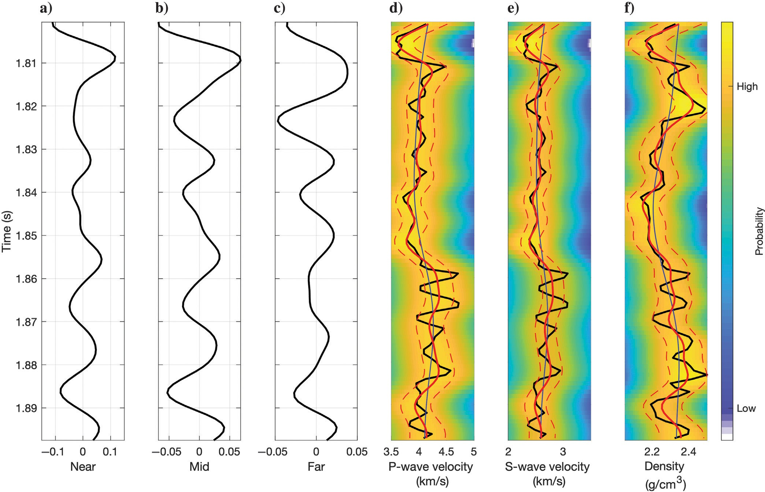
Figure 2. Bayesian linearized AVO inversion: (a–c) input seismic data and (d–f) predictions of P- and S-wave velocities and density. The black lines represent the measured seismograms and well logs, the solid red lines represent the posterior means, the dashed red lines represent the posterior 0.95 confidence interval, and the background color represents the posterior distribution.

Monte Carlo methods

Monte Carlo methods refer to a family of mathematical methods to approximate a PDF of random variables by repeated random sampling. In the context of inverse problems, Monte Carlo methods
are used to draw samples from a prior distribution and accept or reject the proposed model according to the likelihood of the model predictions obtained by applying the forward operator to the sampled model. The posterior distribution of the model variables (equation 2) is then estimated from the set of accepted model real-
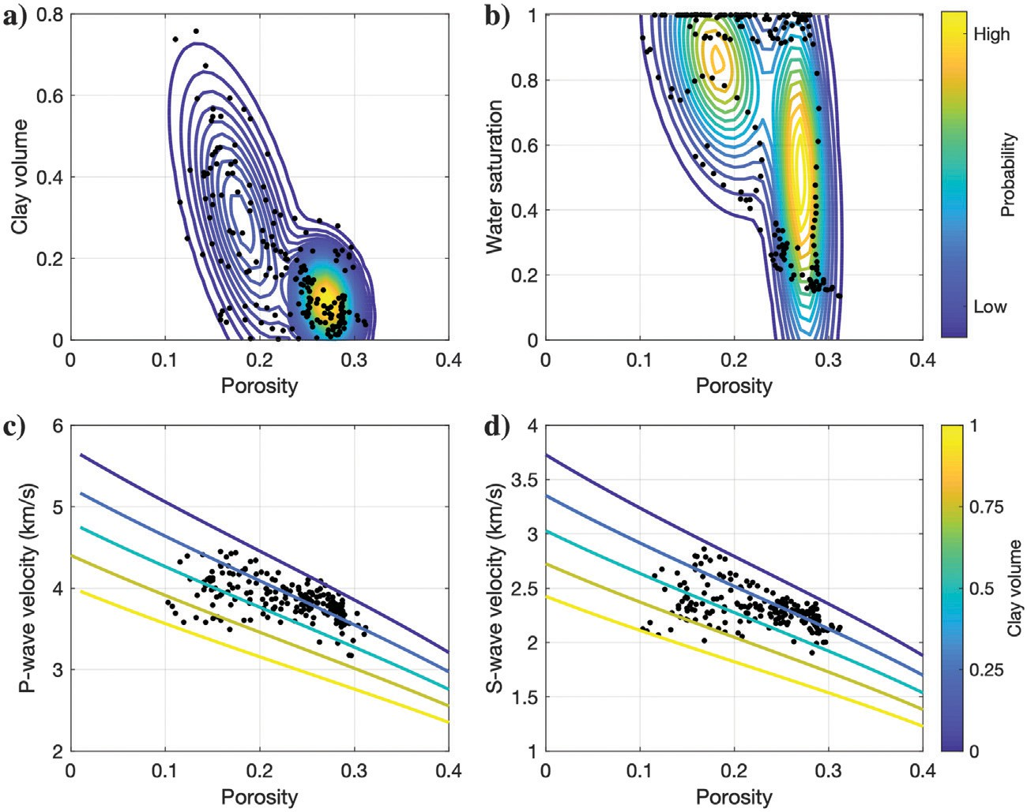
izations.
The simplest implementation of the Monte Carlo approach is the acceptance-rejection sam- pling, as it only requires a sampling algorithm, for example, geostatistical simulation methods, and the forward operator, such as the seismic and rock-physics models. In the context of seis- mic reservoir characterization, the Monte Carlo acceptance-rejection algorithm can be imple- mented by generating pseudologs (i.e., vertical profiles) or 2D/3D realizations of model varia- bles using geostatistical methods such as sequen- tial Gaussian simulation (Doyen, 2007; Grana et al., 2021) according to the prior distribution of the model variables and the prior spatial cor- relation model, computing the synthetic seismic response, and accepting or rejecting the proposed model based on a predefined acceptance cri- terion, such as the crosscorrelation or the L2 norm between the simulated and observed seis- mic data.
González et al. (2008) propose a sequential ap-
proach in which model realizations are generated

Figure 3. Prior and likelihood models of Bayesian Gaussian mixture rock physics in- version: (a and b) prior distribution of petrophysical properties and (c and d) rock-phys- ics model. The black dots represent the well-log data.
using geostatistical simulation conditioned to multiple-point statistics, in which each trace is sequentially visited, and the model realization is accepted or rejected according to the data like- lihood. If accepted, the model realization is re-

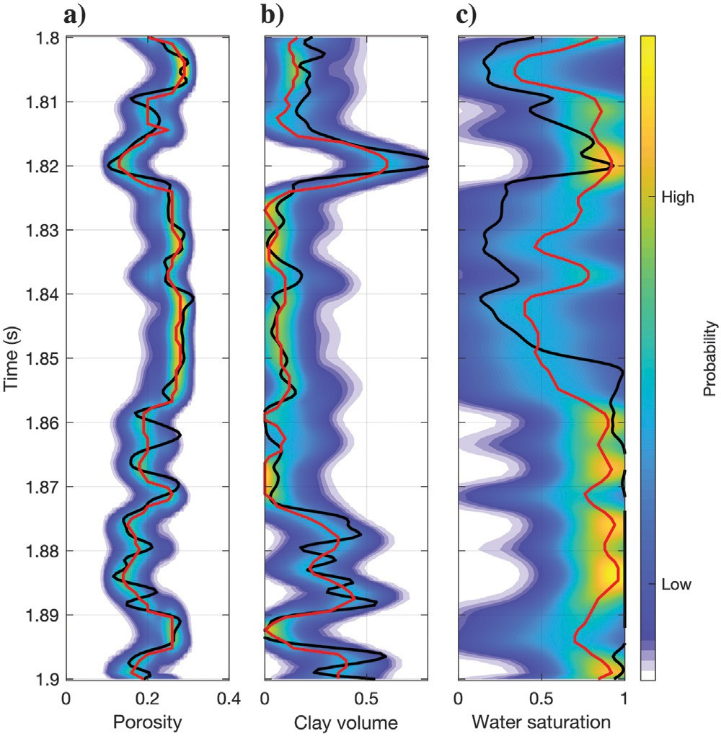
Figure 4. Bayesian Gaussian mixture inversion of seismic data for petrophysical properties: (a) porosity, (b) clay volume, and (c) water saturation. The black lines represent the measured data, the red lines represent the posterior mean, and the background color represents the posterior distribution.
tained; otherwise, it is rejected and simulated again at the next iteration. This idea originated from Bortoli et al. (1993) who origi- nally use variogram-based (two-point) conditional geostatistical simulations instead of multiple-point statistics. Connolly and Hughes (2016) propose a Monte Carlo acceptance-rejection algo- rithm for joint seismic and rock-physics inversion to predict facies and petrophysical properties. The model realizations are sampled from the prior distribution and a vertical correlation model, inde- pendently at each iteration, as opposed to conditional sampling (i.e., MCMC methods) in which the solution is iteratively obtained by perturbing the model obtained in the previous iteration. This method also can be considered part of the approximate Bayesian computation category, as it approximates the likelihood function by simulations and compares the predictions with the measured data. This inversion is based on matching the synthetic response of the pseudowells to seismic data. As sampling is independent at each iteration, no information from the previous iteration is used to condition the simulation in the next iteration; hence, Monte Carlo acceptance-rejection algorithms avoid bias but are computationally demanding. Connolly and Hughes (2016) propose an efficient im- plementation by restricting the size and spatial dimensionality of the samples and sampling in the facies domain. The addition of a local- ized optimization step applied to each accepted realization after a relatively small number of iterations significantly improves the match quality while still retaining the advantage that the samples are independent (Connolly, 2021).

Monte Carlo methods might be computationally demanding especially when the prior distribution is not informative and the al- gorithm samples regions with low likelihood values. To avoid this limitation, a Markov chain is adopted. A Markov chain is a random process in which the probability of moving from the previous state to the current state is defined by a transition probability that depends only on the immediate previous state (and not on the previous ones). Based on this concept, MCMC methods design a random walk in
with

F _{l}(m)= (f(m) − d)TΣ⁻¹(f(m) − d), (8)
e

F _{p}(m)= (m − μ_{m})TΣ⁻¹(m − μ_{m}), (9)
m

the model space using a Markov chain to draw samples. The chain of samples asymptotically converges to a stationary distribution that approximates the posterior distribution of the Bayesian inverse problem. There are different MCMC algorithms, including Gibbs sampling, Metropolis-Hastings, and Hamiltonian Monte Carlo (Sen and Stoffa, 2013; Grana et al., 2021).
In general, in MCMC methods, a sample m is drawn from a pro- posal distribution g m conditioned on the solution at the previous iteration and is accepted or rejected according to a likelihood cri- terion. If accepted, the proposed sample is used to condition the proposal in the next iteration; if rejected, the previous sample is retained. One of the most popular MCMC methods is the Metropo- lis-Hastings algorithm (Hastings, 1970). In the Metropolis-Hastings algorithm, we first draw the initial sample of the chain m₀ from the prior distribution P m ; then, at each iteration, a sample m' is drawn from the proposal distribution g m m_{i} conditioned on the sample m_{i}, and it is accepted with acceptance probability:
( )
( | )
( )
=
p min P(m'|d) × g(m_{i}|m') , 1
a
P(m_{i}|d) g(m'|m_{i})

P(d|m')P(m') g(m_{i}|m')
where the subscripts l and p indicate the likelihood and the prior model, respectively. The Gibbs sampling algorithm (Geman and Geman, 1984) is another special case of the Metropolis-Hasting algorithm in which the proposed sample is drawn from the full conditional distribution of one variable conditioned on the other variables, for which the acceptance probability is always equal to one and the proposed sample is always accepted (Gelman et al., 2013). The Gibbs algorithm consists of computing the desired dis- tribution by performing multiple samplings of each variable given all of the other variables. The main advantage of Gibbs sampling is the reduction of the dimensionality of the problem, by producing a sequence of low-dimension simulations that converge to the target distribution. It is generally applied when the joint distribution is difficult to sample from directly, but the conditional distributions of each variable conditioned on the other variables can be effi- ciently computed, by drawing a sample from the distributions of each variable in turn, conditional on the current values of the other variables.
The posterior distribution of the model variables is then estimated from the samples of the chain, after discarding the initial samples such that the chain loses dependence on the initial sample. The set

= P(d|m )P(m ) × g(m'|m ) , 1
i
i
i
, (6)
of discarded iterations is generally referred to as the “burn-in”
period. It is common to apply the so-called “thinning” of the Mar-

where the normalizing constant P d cancels out in the fraction in equation 6, making the calculation of the accepting probability computationally feasible. If the probability ratio in equation 6 is greater than or equal to one, the sample m' is always accepted; oth- erwise, we generate a random number u ∼ U 0, 1 uniformly dis-
( )
([ ])
tributed. If u ≤ p_{a}, the sample m' is accepted; otherwise, it is
rejected. When the sample is accepted, it becomes the new state
of the chain: m_{i+1} = m'; otherwise, the previous state is retained m_{i+1} m_{i}. The Metropolis algorithm (Metropolis et al., 1953) is a special case of the Metropolis-Hastings method, in which the pro- posal distribution g m m_{i} is symmetric, i.e., g m m_{i} g m_{i} m . Thus, in the Metropolis algorithm, the probability ratio in equation 6 simplifies to the ratio of the posterior probabilities. Hence, if P(m'|d) ≥ P(m_{i}|d), the proposed sample m' is always accepted;
=
( | ) ( | )= ( | )
otherwise, if P(m'|d) < P(m_{i}|d), it is accepted with probability
p_{a} = P(m'|d)∕P(m_{i}|d). If (1) the prior distribution is Gaussian N m; μm, Σm with prior mean μm and prior covariance matrix Σm generally obtained by combining a stationary covariance matrix and a spatial correlation matrix, (2) the likelihood function is Gaus- sian N d; f m , Σe with mean f m and covariance matrix Σε , and
( )
( ( ) ) ( )
(3) the proposal distribution is symmetric, then the acceptance prob-
ability p_{a} is

p = min exp − 1 (F (m') − F (m ))
a 2 l l i
× exp − 1 (F (m') − F (m )) , 1 , (7)
2 p p i
kov chain, i.e., subsampling the chain by taking every kth observa- tion instead of all of them, to obtain samples that are nearly independent and reduce storage costs. The posterior distribution of rock and fluid properties in seismic reservoir characterization is highly dimensional nonconvex. For this reason, to improve the robustness of the inference of the posterior distribution, it is common to run multiple chains for each data trace to ensure con- vergence. An example of the Metropolis algorithm sampling is shown in Figure 5. The rock-physics model is the same as in Fig- ure 3c and 3d. The proposal distribution is assumed to be Gaussian with locally variable means that depend on the previous model and assigned covariance matrix. The spatial correlation model is an ex- ponential function with a correlation length of 5 ms. We apply the MCMC inversion to estimate the posterior distribution of porosity, clay volume, and water saturation. Figure 5 shows 2000 posterior realizations, the estimated posterior distributions, and the posterior mean of the PDFs.
De Figueiredo et al. (2019a, 2019b) propose an MCMC Metropolis-based algorithm to predict facies and petrophysical variables using Gaussian mixture and nonparametric distributions. Each component of the mixture is identified with a facies configu- ration. The sampling algorithm is performed in two steps: in the jump step, a new realization of facies and petrophysical properties is proposed, whereas, in the local step, the previous facies reali- zation is retained and a new realization of petrophysical properties is sampled. This algorithm allows jointly sampling facies and petrophysical realization from high-dimensional multimodal dis- tribution.

Stochastic optimization
Stochastic optimization methods are mathematical algorithms for the prediction of the optimal solution (or set of solutions) with re- spect to a predefined criterion. Geophysical inverse problems can be formulated in a stochastic optimization framework by defining an
objective function J m that represents the misfit between the mea- sured data and the geophysical operator predictions d~:
( )

J(m)= d − d~ + Γm = d − f(m) + Γm , (10)
Ensemble-based methods represent a family of stochastic optimi- zation algorithms in which an ensemble of model realizations is generated, for example, using geostatistical methods, and then up- dated according to a Bayesian updating step. The conditional dis- tribution of the model variables is approximated by estimating the sample mean and covariance matrix from the ensemble. The ES- MDA (Emerick and Reynolds, 2013) is an iterative method. First, we define the number of ensemble models n_{e} and the inflation fac-
tors α_{i} for i 1, ..., n_{a}, with ^{n}a 1∕α_{i} 1, where n_{a} is the
i=1
{ } = P ( )=
number of iterations. Then, we generate an ensemble of prior real-
izations {m^{i=1}} of the model variables, for j = 1, ..., n_{e}. At each
j

and minimizing it to find the optimal solution m^ :
iteration i = 1, . .. n_{a}, we apply a perturbation to the measured data

d^{i} = d + ,ﬃαﬃﬃﬃΣ^{1∕2}z^{i} , where Σ
p_{j}
i
e
p_{j}
e
measurement errors and the random vector z^{i}
is the covariance matrix of the

m^ = argminm(d − f(m) + Γm ), (11)
0 mean and identity covariance matrix for j
p_{j}
, ...,n . We then
is Gaussian with

= 1 e
apply the forward operator f to the ensemble of models {m^{i} } to

where Γ is a Tikhonov regularization parameter (Aster et al., 2011), often assumed to be the product of a scalar and the identity matrix Γ αI. The Gaussian prior term P m N m; μm, Σm) in Baye- sian inversion (equation 3) is equivalent to the regularization term
= ( )= (
{ } =
j e
j
compute the predicted data d^{i} for j 1, ..., n . The ensemble
models m^{i} are then updated according to a Bayesian step to obtain the ensemble models m^{i+1}:
j
j
i

Γm with respect to the L2 norm (equation 10), with prior covari-
m^{i+1} = m^{i} + Σ^{i} (Σ
+ α_{i}Σ_{e})−1(d^{i} − d^{i} ), (12)

ance Σm = Γ^{T}Γ.
j j m,d
d,d
pj j

In stochastic optimization, the solution m is iteratively stochasti-
for j = 1, ..., n_{e}, where Σ^{i}
is the cross-covariance matrix of

cally perturbed to minimize the value of the objective function. Sev- eral stochastic optimization algorithms based on sequential sampling
Σ
models m^{i}
m,d
and predicted data d^{i} and
i d,d
is the covariance matrix

have been proposed for geophysical inverse problems, including gradual deformation, probability perturbation method, ensemble smoother, simulated annealing, genetic algorithms, and deep learning algorithms (Grana et al., 2021). These algorithms differ for the def- inition of stochastic perturbation and the optimization process. For illustration purposes, we describe in detail the ensemble smoother algorithm.
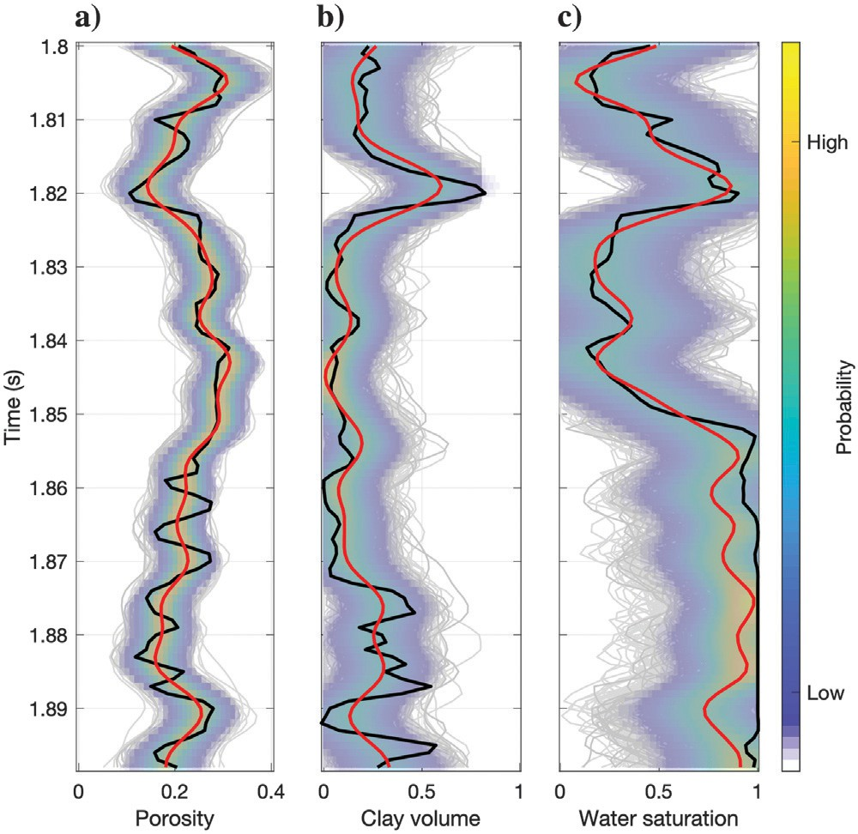
Figure 5. MCMC inversion of seismic data for petrophysical prop- erties: (a) porosity, (b) clay volume, and (c) water saturation. The black lines represent the measured data, the red lines represent the posterior mean, the gray lines represent the posterior realizations, and the background color represents the posterior distribution.
of the data d^{i}, and they are approximated with the empirical covari-
ance matrices estimated from the ensemble. The ensemble models are iteratively updated until the fixed number of data assimilations n_{a} is reached. Localization methods often are necessary to avoid the collapse of an ensemble, i.e., only one ensemble member carries significant weight and the posterior variance converges to zero, es- pecially with large data sets such as seismic surveys (Chen and Oliver, 2017). An example of the inversion using the ES-MDA al- gorithm is shown in Figure 6, assuming the rock-physics model in Figure 3c and 3d. The initial ensemble includes 1000 realizations of porosity, clay volume, and water saturation, generated according to a prior Gaussian distribution and an exponential function with a correlation length of 5 ms. We apply the ES-MDA inversion with four data assimilation steps with constant inflation factors and ob- tain the posterior realizations of clay volume and water saturation. Figure 6 shows the 1000 posterior realizations, the estimated pos- terior distributions, and the posterior mean of the realizations. The uncertainty is generally slightly underestimated compared with the MCMC case in Figure 5.
The gradual deformation method (Hu, 2000) is a stochastic sam-
pling approach in which two independent Gaussian model realiza- tions are gradually perturbed, according to a deformation parameter θ ∈ 0, π∕2 . We can then sample multiple realizations
[ ]
by sampling values of θ. The gradual deformation method can be
used as a stochastic optimization approach by iteratively sampling multiple realizations and choosing the realization that maximizes the likelihood of the data predictions or minimizes the misfit between the measured and predicted data (Le Ravalec, 2005). Such an ap- proach transforms a multidimensional optimization into a sequence of 1D optimizations. The probability perturbation method (Caers and Hoffman, 2006) is a stochastic optimization algorithm similar to the gradual deformation method. However, in the probability perturba- tion method, the perturbation is applied to the probability distribution used to generate the model realizations rather than the realization it- self. In this approach, at each iteration, a new probability distribution

is defined as a convex combination of the conditional probability obtained in the previous iteration and the prior probability. Several other stochastic optimization methods have been applied to geophysi- cal inverse problems, including simulated annealing, particle swarm optimization, and genetic algorithms (Sen and Stoffa, 2013) as well as deep learning algorithms.

Probabilistic deep learning
Deep learning relies on the concept of an artificial neural network (Bishop, 1995; Goodfellow et al., 2016). With the recent advances in the field of artificial intelligence and high-performance computing, data-driven methods developed in computer science and based on deep learning have been applied to seismic inverse problems for the classification and prediction of reservoir properties (Bhattacharya, 2021; Bhattacharya and Di, 2022). In the context of inverse problems,
the goal of deep learning is to find an approximation g ≅ f⁻¹ of the inverse function of the forward operator f (equation 1). In a generic
neural network with L hidden layers, the model variable of interest m is represented as a function of the hidden states z as
m = h(w_{L}z_{L} + b_{L}), (13)
with
z_{l} = g(w_{l−1}z_{l−1} + b_{l−1}), (14)
ces. Long short-term memory is based on the gate mechanism, in which the value of the cell state at each time step is determined by the current value and the value at the previous time step, according to the update and forget gate, and the activation output is then regu- lated by the output gate. We adopt a simple network with a long short- term memory layer, a time-distributed layer, and a fully connected layer with SoftMax as the activation function to map logits into prob- abilities and output the probability distributions. The data set includes a reference facies model including sand, shaly sand and shale, and a seismogram corresponding to a zero-offset trace (Figure 7). We first generate a training data set of s 10, 000 realizations of facies using a Monte Carlo method assuming first-order stationary Markov chains. In each facies, we sample porosity, calculate P-impedance using a linearized rock-physics model, and compute the seismogram using a convolutional model. We then apply the recurrent neural network method to the measured seismogram. The recurrent neural network includes one long short-term memory layer of 50 units, and the opti- mizer is the RMSprop with a learning rate of 0.001 and a moving average parameter of 0.9. The data set is randomly split into two sub- sets with 90% of the samples in the training set and 10% of the sam- ples in the validation set. The optimal model is obtained around epoch
30. The classification results are shown in Figure 7. The predicted facies match the reference profile well, even though some thin layers are not correctly predicted. The facies probabilities capture the uncer- tainty in the interval with higher entropy.
=

for l = 1, ..., L, where {w}_{1,..} . _{,L}
and {b}1,. .. ,L
represent the
Many applications of deep learning in seismic reservoir characteri-
zation focus on categorical problems, such as facies or rock-type clas-

weights and biases of the network, respectively, whereas g and h re- present the activation functions. Probabilistic models also can be in- tegrated with the neural network to obtain a probabilistic distribution in the output. Weights and biases can be considered stochastic var- iables to make the neural network a deep learning algorithm.
A comprehensive automated solution to the seismic reservoir char- acterization problem is still missing; however, deep learning and probabilistic deep learning algorithms have been applied to several steps of the modeling workflow, including seismic facies classifica- tion, reservoir characterization, fault detection, and salt segmentation. Recent advances in deep learning including CNNs, recurrent neural networks (RNNs), and GANs have been applied to seismic and pet- rophysical inversion (Biswas et al., 2019; Das et al., 2019; Mosser et al., 2020; Sun et al., 2021). Probabilistic approaches to the neural network have been presented in Roth and Tarantola (1994), Saggaf et al. (2003), Shahraeeni and Curtis (2011), and Shahraeeni et al. (2012). These algorithms differ in the architecture of the neural net- work. For illustration purposes, we show an example of the applica- tion of an RNN to a facies classification problem.
Unlike traditional neural networks, such as multiple layer percep- tron and convolutional neural networks, recurrent neural networks allow information cycles through a feedback loop and thus account for the input at the current time step and the information learned from previous time steps. The main advantage of recurrent neural networks is that they can capture temporal dependencies in the input data, mak- ing them suitable for seismic reservoir characterization problems in which the seismic data are collected as time signals. In general, recurrent neural networks include hidden layers serving as state memory to store the information learned from previous time steps; however, in practical applications, they might fail when training with long sequences of data. For this reason, recurrent neural networks using gated units, such as long short-term memory (Goodfellow et al., 2016), have been developed to make them suitable for data sequen-
sification (Liu et al., 2019; Feng et al., 2021; Talarico et al., 2021) as in the example previously; however, deep neural networks also have been applied to inverse problems for the prediction of continuous
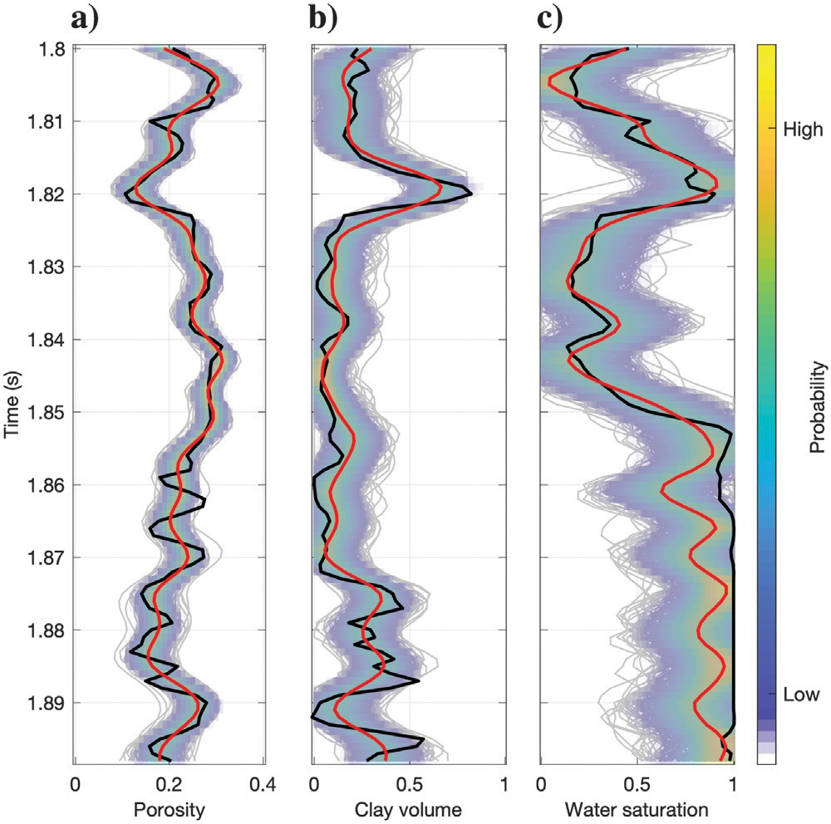
Figure 6. Ensemble smoother inversion of seismic data for petro- physical properties: (a) porosity, (b) clay volume, and (c) water sat- uration. The black lines represent the measured data, the red lines represent the posterior mean, the gray lines represent the posterior realizations, and the background color represents the posterior dis- tribution.

properties, such as petroelastic variables (Roth and Tarantola, 1994; Saggaf et al., 2003; Shahraeeni and Curtis, 2011; Shahraeeni et al., 2012; Mosser et al., 2020; Zhang and Curtis, 2021a, 2021b). Probabilistic neural networks also can be formulated in a Bayesian setting. Given a data set d with n measurements with independent Gaussian distributed errors with variances σ² for i 1, . .., n,
i
=
and given a neural network with parameters θ including weights
w and biases b, then the likelihood can be written as
P(d|θ)= Y N(f(m(θ)) ; d , σ²), (15)
n
methods. All these algorithms can be applied to a large variety of geophysical inverse problems, including seismic AVO and rock-physics (or petrophysical) inversion and facies classification, as well as seismic full-waveform and electromagnetic inversion. However, probabilistic methods for seismic reservoir characteriza- tion can be classified according to the model parameterization, the input data, or the physical models assumed for the forward operator of the inversion.
Another popular classification of seismic reservoir characterization algorithms for the prediction of rock and fluid properties of the res-

i=1
i i i
ervoir discriminates between single-loop inversion and multistep (or sequential) inversion. In a single-loop inversion, the input data are the

where m is obtained as in equations 13 and 14. Then, the posterior of the neural parameters can be computed using Bayes’ rule,
P θ d P(d|θ)P(θ) , (16)
( | )=
P(d)
and the posterior realizations of the model variable of interest can be obtained by randomly drawing the neural parameters, hence by cre- ating a proposal distribution in a sampling-based approach.

DISCUSSION
The proposed classification of methods defined in the “Introduc- tion” section aims at defining the main feature of the mathematical approach used to solve the inverse problem, i.e., analytical PDFs, sampling algorithms, optimization techniques, or deep learning
seismic amplitudes and traveltimes, and the inversion generally in- cludes a seismic model, a rock-physics model, and in some cases a facies classification (Bosch et al., 2007, 2009; González et al., 2008; Connolly and Hughes, 2016; Jeong et al., 2017; Aleardi et al., 2018; Gunning and Sams, 2018; Bachrach and Gofer, 2020; Heidari et al., 2022). As the combined seismic and rock-physics model is gen- erally nonlinear, the analytical solution is generally not available and numerical algorithms are generally adopted. For large applications, algorithms based on linearized models or 1D approximations often are adopted to reduce the computational time. In a multistep inversion, seismic data are first inverted to estimate the corresponding elastic properties; then, elastic properties are inverted to predict the petro- physical properties and/or classified in facies (Larsen et al., 2006; Bu- land et al., 2008; Grana and Della Rossa, 2010; Ulvmoen et al., 2010; Shahraeeni et al., 2012; Aleardi et al., 2018; de Figueiredo et al., 2018). In the multistep approach, different algorithms can be used for the different inversion steps, and probabilistic inversion methods also can be applied to seismic inversion results ob-
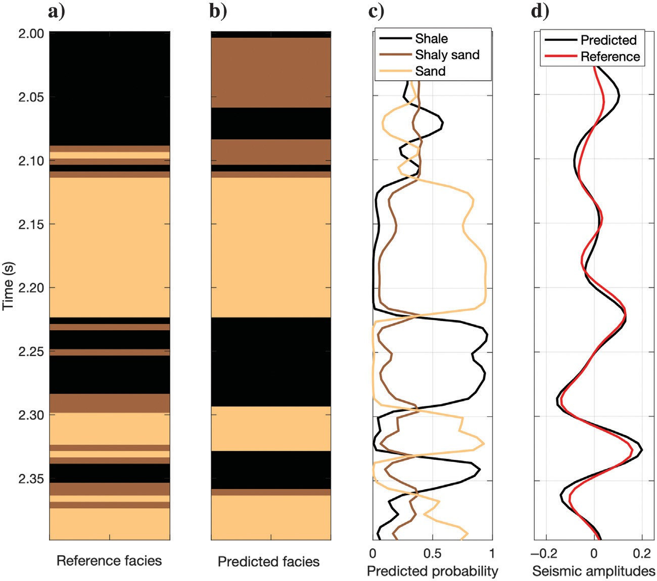
tained using deterministic methods. The multistep approach often relies on a linearized AVO inver- sion (e.g., Buland and Omre, 2003) and allows treating the rock-physics inversion as a pointwise problem. However, one of the challenges in the multistep approach is the propagation of the un- certainty through the different steps. Grana and Della Rossa (2010) propose a statistical approach based on the Chapman Kolmogorov equation to propagate the uncertainty from the seismic inver- sion step (i.e., Bayesian linearized AVO inversion) to the petrophysical domain (i.e., Bayesian petro- physical inversion). In single-loop and multistep methods, multiple parameterizations can be adopted for the petrophysical variables, including porosity, mineral volumes, and fluid saturations, as well as for the elastic formulation, including velocity, density, impedances, or other seismic attributes. Advanced rock-physics and seismic models accounting for the anisotropy, stress, and fracture properties also can be included in the in- version (Bachrach and Gofer, 2020).
Bayesian analytical inversion, MCMC, and en-
semble-based methods are implemented in the open-source SeReM package, available in MAT- LAB (Grana et al., 2021) and in Python (Grana

Figure 7. Seismic facies classification using recurrent neural network: (a) reference facies classification, (b) predicted facies, (c) predicted facies probability, and (d) seismic response (predicted data in black and reference data in red).
and de Figueiredo, 2021), whereas inversion algo- rithms with the complex prior information can be found in SIPPI (Hansen et al., 2013). The Tensor-

Flow Probability library is designed to combine probabilistic models with deep learning (Dürr et al., 2020) and has been applied to seismic inverse problems for reservoir characterization (Liu and Grana, 2019). The quality of the inversion can be assessed according to multiple metrics. For continuous properties, the accuracy of the inversion can be quantified using the root-mean-square (rms) error and the lin- ear correlation coefficient. The rms error represents the square root of the quadratic mean of the differences between predicted and measured values (i.e., the residuals). Similarly, the linear correlation coefficient is computed between predicted and measured values. In particular, for time signals, evaluating both metrics provides a better assessment of the inversion accuracy, as time-shifts, biases, or trends may affect the metrics evaluation. For example, a time-shift in the predictions gen- erally has a large effect on the rms error but does not affect the linear correlation between predicted response and measurements. To assess the precision of the inversion, the coverage ratio of a given confidence interval, for example, the 0.90 coverage ratio, can be adopted. The
0.90 coverage ratio of the predictions defines the fraction of measured samples within the 0.90 confidence interval. Hence, the optimal 0.90 coverage ratio is 0.90, i.e., when 90% of the measured samples are within the predicted 0.90 confidence interval. For categorical proper- ties, contingency (or confusion) analysis also is adopted, if reference values of the categorical property are available for a portion of the data set (e.g., a facies classification profile at the well location). This analy- sis is based on the absolute frequencies as well as reconstruction and recognition rates. The absolute frequencies count the number of refer- ence samples classified in the predicted facies, whereas the reconstruction and recognition rates are obtained by normalizing the absolute frequencies by the total number of reference and pre- dicted samples in each category (Grana et al., 2021).
Overall, all of the presented methods can be applied to exploration or production settings; however, some algorithms might be more suit- able for complete data sets. For example, supervised deep learning often requires a large data set that is generally not available in the exploration phase. Similarly, sampling algorithms often require a spa- tial correlation model to build realistic reservoir realizations, and the calibration of the spatial model parameters often is uncertain for sparse data sets. Especially in the exploration phase, addi-
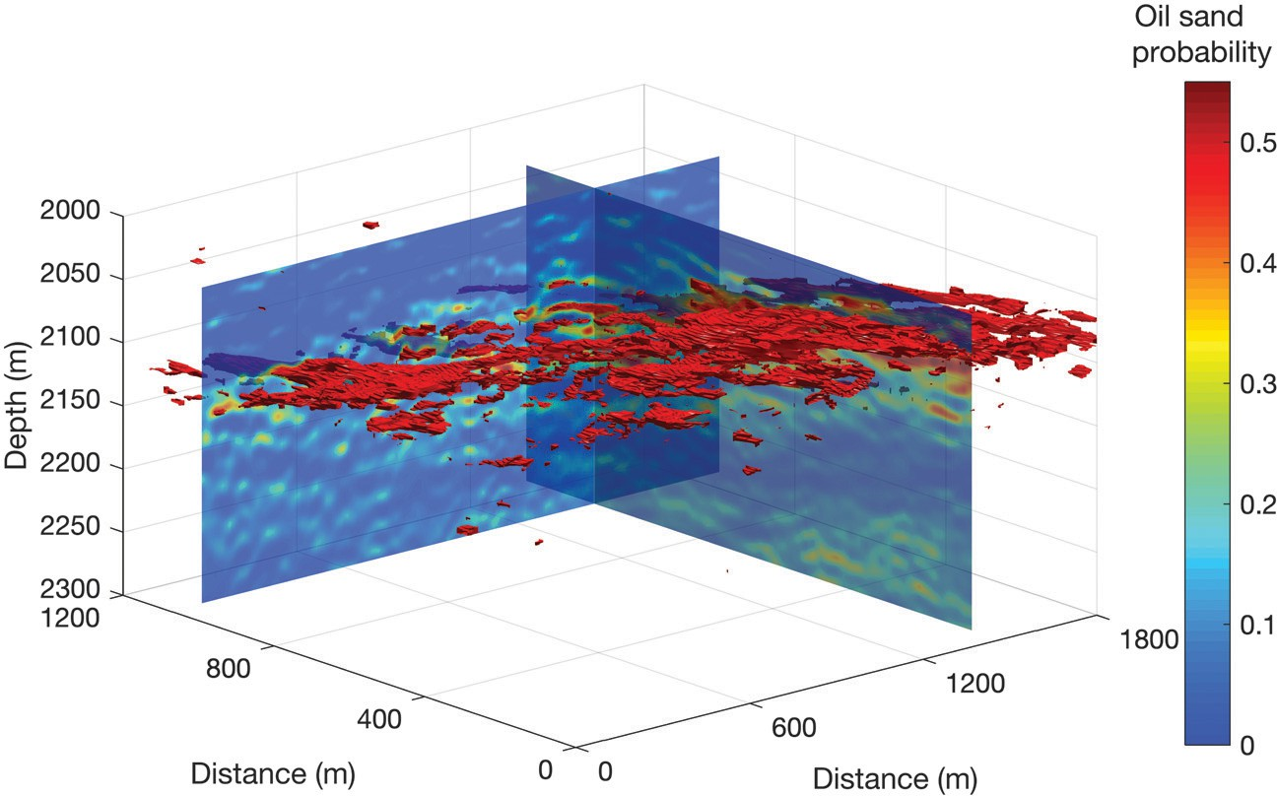
tional prior information from different sources can be integrated with the Bayesian setting to reduce the uncertainty of the model. In the rock-physics inversion, core samples and well logs are com- monly adopted for the calibration of the rock-phys- ics model and likelihood function. These models also can be adopted to expand the training data set in supervised learning, to mimic geologic sce- narios not sampled by well-log data. Most of the case histories include data sets from the North Sea (Avseth et al., 2001; Mukerji et al., 2001b; Eidsvik et al., 2004a; Tetyukhina et al., 2010; Rimstad et al., 2012); however, several case histories have been presented all around the world including Gulf of Mexico (Contreras et al., 2006, 2007; Bui et al., 2011), Nile Delta (Aleardi and Ciabarri, 2017), and Middle East (Kumar et al., 2018), among the others. Grana and Della Rossa (2010) apply the Bayesian Gaussian mixture rock-physics inversion
fluvio-deltaic environment of the Middle-Late Triassic age that presents a sequence of sand and shaly layers. The seismic data set consists of four angle stacks. The rock-physics relation is based on Dvorkin’s stiff sand model as it is calibrated using a set of well- log data. The inversion is applied to a seismic subvolume of 10,000 traces in a depth interval of approximately 250 m. Figure 8 shows the 3D isosurface of 0.7 probability of oil sand, which identifies the main reservoir layer. The inversion is performed trace-by-trace and the calculation of the analytical solution takes approximately 8 min on a standard workstation. De Figueiredo et al. (2018) apply an MCMC method based on the Gibbs sampling algorithm for the seismic and rock-physics inversion of 3D seismic data in an oil-saturated carbonate field, offshore Brazil. The seismic data set includes three partial angle stacks. Three lithofluid facies are defined based on core samples: oil- saturated high-porosity carbonate, partially oil-saturated midporosity carbonate, and low-porosity carbonate. Figure 9 shows the 3D isosur- face of 0.65 probability of high-porosity carbonate. The Gibbs sam- pling algorithm in de Figueiredo et al. (2018) takes approximately
10 h on a standard workstation for a 3D seismic volume of
141,750 traces with 312 samples per trace.
The application of probabilistic inversion methods for seismic res- ervoir characterization presents several challenges. The calibration of the rock-physics model often is difficult due to the approximations of the physical models and the different physical relations in different facies. The application of facies-dependent rock-physics relations re- quires a facies classification model, which is generally unknown. Re- cent advances in machine learning allow performing the rock-physics inversion without an explicit formulation of the rock-physics relations; however, these algorithms are generally based on implicit relations inferred from a training data set. The construction of the training data set often requires a spatial model as well as rock-physics models cov- ering all facies of interest in the target zone. A biased training data set might severely affect the inversion results. The application of fully stochastic methods to large 3D seismic data sets also is challenging due to the large computational costs. One of the main advantages of stochastic methods is the quantification of the uncertainty of the model variables; however, accurate uncertainty quantification might require a

to a 3D seismic data set acquired in a clastic res-
ervoir, offshore Norway. The reservoir is part of a
Figure 8. Isosurface of 0.7 probability of oil-sand lithofluid class. The background slices represent two 2D sections of porosity (modified after Grana and Della Rossa, 2010).

large computational cost in practical applications. The curse of dimen- sionality is one of the many challenges in practical applications in seismic reservoir characterization and model realizations or 1D ap- proximations often are adopted to make the computation feasible. For example, hybrid algorithms combining geostatistical sampling and optimization have been proposed in which the model realizations are sampled in a 3D space but the optimization is performed trace-by- trace. Similarly, sampling algorithms based on proposal distributions obtained from linearized models can be adopted to draw samples from a proposal distribution that approximates the posterior distribution. The implementation of the algorithm, the ability to parallelize the code, and the node availability largely affect the computational costs of the proposed methods. Furthermore, standard practices in seismic reservoir characterization do not often use this additional information. Fluid-flow simulation models are generally applied to deterministic models; hence, the uncertainty information obtained in seismic reser- voir characterization often is neglected (Grant et al., 2020). The inte- gration of the posterior distribution in fluid-flow simulation models is an ongoing research topic and it focuses on the development of sto- chastic fluid-flow simulation methods in which the initial conditions are described by probability distributions.
Several research directions have been developed in the recent liter- ature on seismic reservoir characterization. Probabilistic inversion methods can generally be applied to any rock-physics model, includ- ing petrophysical, geomechanical, and geochemical relations. These multiphysics models are especially useful in complex reservoir struc- tures with fractures and in CO₂ sequestration operations in which geo- chemical effects can play an important role. Most of the available Bayesian inversion methods assume Gaussian distributions of the prior model for the analytical tractability of the PDF; however, prob- abilistic methods with non-Gaussian assumptions, including Gaussian mixture, skewed-Gaussian, beta, and Dirichlet distributions, can be developed. Complex prior models including spatial correlation struc- tures also can be adopted in probabilistic seismic and rock-physics inversion to improve the geologic realism of the predicted models (Linde et al., 2015). Due to the large dimensions of the model and
data spaces, to speed up the inversion algorithm, dimensionality re- duction methods can be applied to the model variables and the mea- sured data to reduce the number of parameters in the inversion and perform the inversion in lower dimensional spaces. Examples of these methods include multidimensional scaling (Azevedo et al., 2014), sin- gular value decomposition (Tompkins et al., 2011; Glinsky et al., 2015), correlation analysis (Alvarez et al., 2015), and deep learning algorithms (Canchumuni et al., 2019; Liu and Grana, 2020). However, dimensionality reduction of the model or data domains might affect the uncertainty predictions. Indeed, a reduction of the dimension of the model variables generally makes the problem overdetermined leading to a potential underestimation of the uncertainty, whereas a reduction in the dimension of the data generally makes the problem underde- termined leading to a potential overestimation of the uncertainty.
When the forward model is not completely known, or the inverse operator is mathematically untreatable, deep learning methods also can be adopted for the approximation of the inverse operator asso- ciated with the unknown geophysical models. Current research di- rections in deep learning focus on probabilistic approaches in which weights and biases of the neural network are sampled from a pos- terior distribution to obtain realizations of the model variables in Bayesian and frequentist settings.

CONCLUSION
Probabilistic inversion of seismic data for the estimation of reservoir properties is a necessary tool for seismic reservoir characterization studies to quantify the rock and fluid properties and to assess their uncertainty. Most of the methods available in the literature are based on a Bayesian approach, and they generally differ from each other in the model parameterization, the formulation of the physical problem, the inversion algorithm, and the spatial constraints. Probabilistic inver- sion can be performed according to analytical approaches, in which the posterior distribution of the Bayesian inversion problem is ex- pressed in a closed form, or numerical methods, in which the posterior distribution is approximated by iteratively sampling and perturbing a set of model realizations. In analytical methods, the uncertainty of the model variables is expressed by the posterior dis-
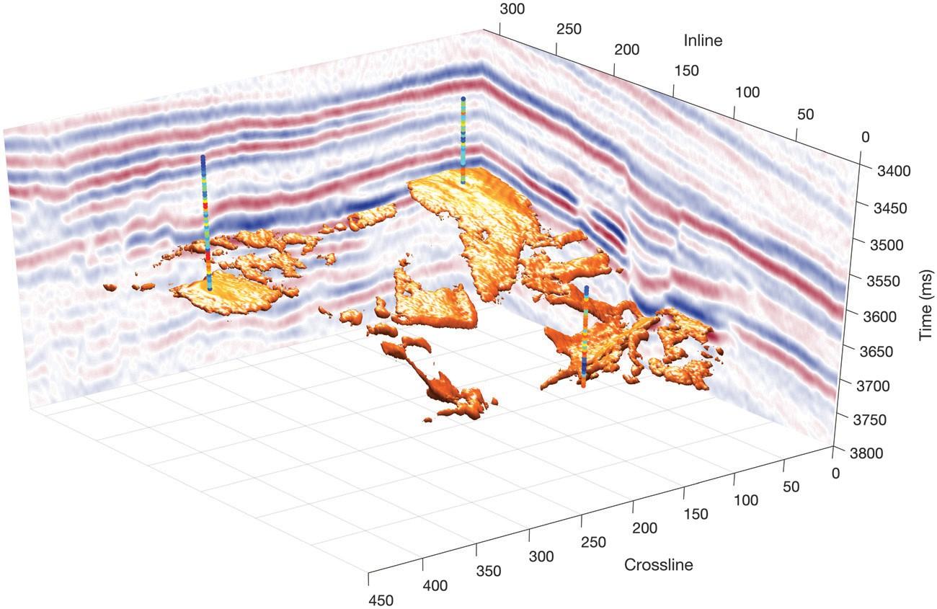
tributions, whereas, in numerical methods, it is generally represented by a set of model realiza- tions. Probabilistic inversion methods have been proven to be accurate and precise in the estimation of the posterior probability of petrophysical prop- erties even though the quantification of the prior uncertainty might be affected by subjective inter- pretations of the multiple sources of variability. In current best practices, the uncertainty information is not always used in forecasting and decision- making processes, due to the computational cost of fluid flow simulation methods; however, exper- imental design methods as well as dimensionality reduction and clustering analysis can be applied to reduce the number of stochastic realizations ob- tained from inversion or sampling, to select a sub- set of models that represent the uncertainty of the original set of reservoir models. It is critical that the uncertainties in the petrophysical inversion be con- veyed quantitatively to the engineers downstream

Figure 9. Isosurface of 0.65 probability high-porosity carbonate. The background slices represent two 2D sections of seismic amplitudes (modified after de Figueiredo et al., 2018).
for reservoir performance forecasting and deci- sion-making under uncertainty.

